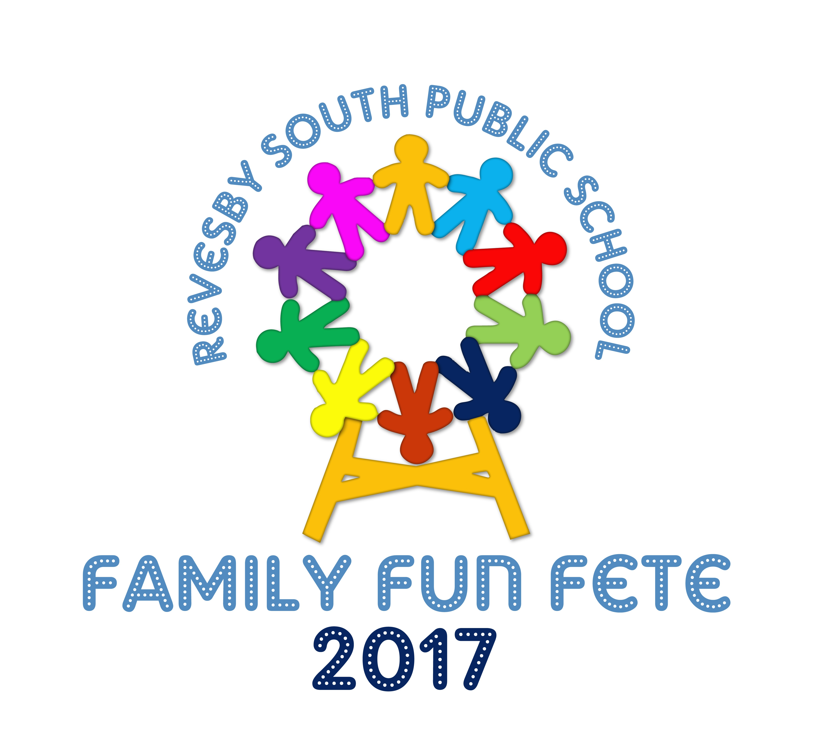

# 



**REVESBY SOUTH PUBLIC SCHOOL**

Mars St Revesby NSW 2212

Phone: (02) 9773 8886

Fax: (02) 9792 3958

School Email: [revesbysth-p.school@det.nsw.edu.au](mailto:revesbysth-p.school@det.nsw.edu.au)

Website: [www.revesbysth-p.schools.nsw.edu.au](http://www.revesbysth-p.schools.nsw.edu.au)

3rd March 2017

RSPS Garden Club Chicken Roster Term 1, 2017

Dear Parents,

What a great turn out we’ve had so far for Garden Club 2017. As stated in the garden club note that went home a few weeks ago, we are responsible for the addition of four chickens to the Garden Club this year.

Below is a roster for the remainder of this term, as well as the coming school holidays, which may include your child/children.

Students will need to let the chickens out, once they arrive at school, and then lock the chickens in once the bell rings each day of the school week.

Students who have been allocated a school holiday will need to change the chickens twice during the week. The chickens will remain locked in their coop for this time. Holiday helpers will get to keep the eggs for breakfast!

If your child is unable to commit to these responsibilities, please let me know as soon as possible as it is important that the chickens remain safe each night.

Thank you for all your support so far,

Happy Gardening,

Mrs Mills

|  |  |  |  |
| --- | --- | --- | --- |
| **Week** | **Stage 1** | **Stage 2** | **Stage 3** |
| Week 7 | Adele | James | Oliver |
| Week 8 | Tempest | Katrina | Sasha |
| Week 9 | Mariam | Ruby | Blake |
| Week 10 | Olivia | Todd | Renee |
| First Week of Holidays | Maya* | | |
| Second Week of Holidays | Charli * | | |

*any two non-consecutive days of the holidays please. Thank you!