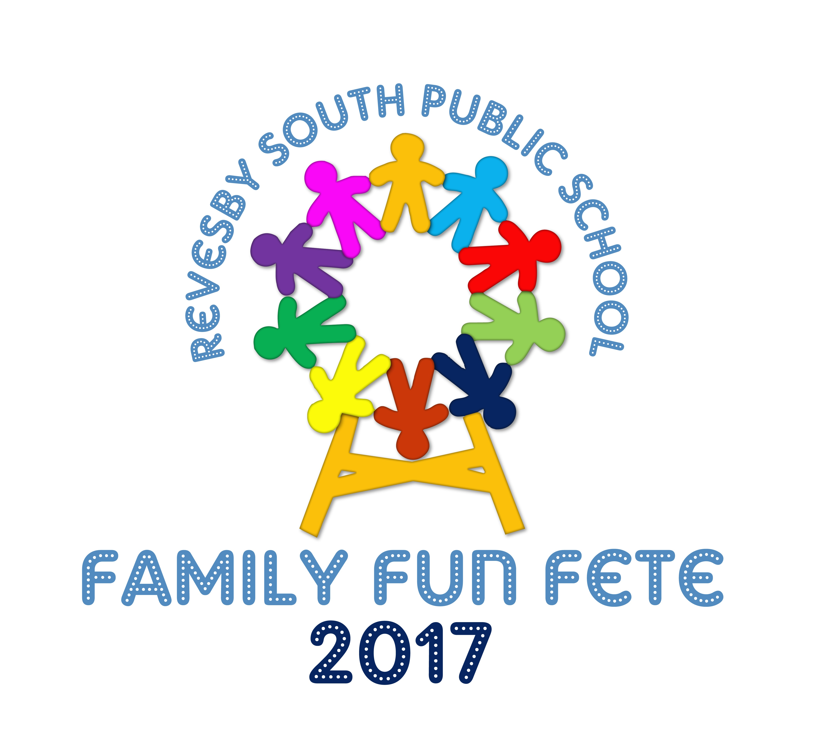

# 



**REVESBY SOUTH PUBLIC SCHOOL**

Mars St Revesby NSW 2212

Phone: (02) 9773 8886

Fax: (02) 9792 3958

School Email: [revesbysth-p.school@det.nsw.edu.au](mailto:revesbysth-p.school@det.nsw.edu.au)

Website: [www.revesbysth-p.schools.nsw.edu.au](http://www.revesbysth-p.schools.nsw.edu.au)

16 February 2017

**GARDEN CLUB 2017**

Dear Families,

Your child has indicated an interest in joining the Revesby South Garden Club for 2017. There has been a large number of students wanting to join this year, and while we will endeavour to include everyone I would appreciate if you could take the time to talk to your child about the responsibilities involved and both sign below if you believe it is something you can commit to.

Garden Club is a fantastic way for students to experience hands on work in the natural environment. Students will learn how to prepare garden beds, plant, water and feed both vegetables and fruit as well as sell their produce to the school community. This year we will also be introducing chickens to the Revesby South Garden. We will collect their eggs and use their manure in our compost, closing the waste cycle and making our garden truly waste free.

Garden Club will run on a Friday morning at 8:30am. The reason for this time slot is a result of teacher duties during lunch and recess and also because it is much cooler to be toiling away in the morning, rather than midday.

The responsibilities that both you and your child will need to take on, should they chose to come to garden club, are listed below:

* A willingness to arrive at school no later than 8:30am Friday mornings (rain, hail or shine).
* A willingness to take part in a roster that includes opening the chicken coop before school and after school each day.
* A willingness to get dirty when digging, mixing compost, cleaning the worm farm and cleaning the chicken coop.
* A willingness to care for the chickens over school holidays periods (making sure they have enough food and water every few days and collect their eggs).
* A desire to commit to making garden club a priority throughout the year, as it will continue during PSSA seasons as well as the RSPS Life Skills program.

Thank you for your time,

Happy Gardening

Mrs Mills

Class Teacher

[Rebecca.hill9@det.nsw.edu.au](mailto:Rebecca.hill9@det.nsw.edu.au)

**GARDEN CLUB 2017**

(please tick the appropriate box and return to Mrs Mills)

Dear Mrs Mills,

My child and I have discussed the responsibilities involved in garden club this year and have decided we would love to take part. We are willing to be at school early on Fridays and can commit to some school holidays.

Student:____________ Parent:_______________

Dear Mrs Mills,

My child and I have discussed the responsibilities involved in garden club this year and have decided we have too many other commitments but might be able to join in at a later date.

Student:____________ Parent:_______________